USQTweet – Simple Twitter App

# Description

USQTweet is a simple tweet client application that is created for Mobile Module in USQ. You can use this application to view the latest tweet posted by you and people that you are following on your Android phone.

Note that you need to have a twitter account and your phone needs to have the internet connection (either 3G or Wi-Fi) in order to use this application.

# App Screenshots

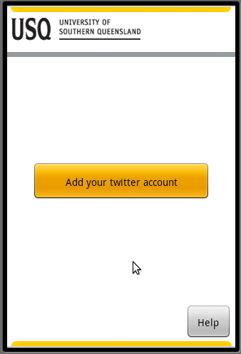 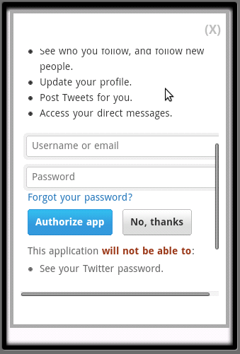 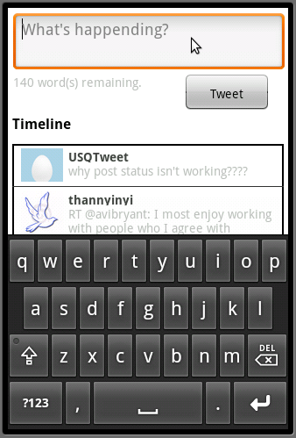

# What's New?

As this application is created to demonstrate how to use Android API from Titanium, it doesn’t have that much functionality for user. It allows you to login with your existing twitter account and view your latest tweets. As twitter site is using oAuth 1.0, we are not going to store your user name or password in this application or your phone.

**User Features**

* Login with existing twitter account
* View the latest tweets on mobile phone

**Technical**

* Demonstrate how to use oAuth
* Network I/O
* Dual orientation GUI
* File API: Persistent storage using "Isolated storage"
* Use of Web View within the app

# Supported Android versions

* 2.2 and up

Note: I tested this application with 2.2 only but hopefully, it will work on newer version as well.